Regression.US_FullFlow_15-Nov-2017 07-28-12 PM.png

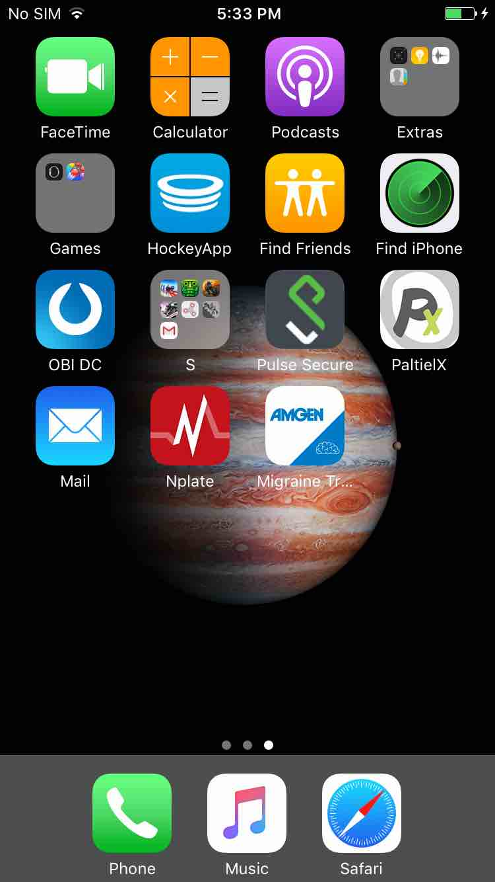

Regression.US_FullFlow_15-Nov-2017_07-28-19_PM.png

